**Bills Ledger**

**Objective**

Ledger is a summary of all the transactions used in the company.

A ledger consists of 3 things:

* Expenses
* Funds
* Transfer Funds

**Essentials For Project**

1. **Login Page**

* User Login
* Admin Login

**User Page**

* Dashboard
* Funds

1. **Admin Page**

* Dashboard
* User
* Funds

**Procedure**

First of all there is a login page which consists of USER ID, PASSWORD and LOGIN button. We need to fill the details and submit the login button.

In Login there are two types. There are

1. User Login
2. Admin Login

|  |  |
| --- | --- |
| USER ID  PASSWORD     |  | | --- | | **LOGIN** | |

* After clicking the login button the page redirect to the user or admin page. The user page contain Dashboard ,Funds Button ,Profile of the user and logout button.
* When user clicks on the Dashboard Button it displays Expenses card and Remaining Funds card.
* When Admin Login’s user button will be displayed extra along with user page content.
* When the Admin Login and clicks on the user button, it should display Active User names. If the Admin wants to add the new person name or delete the person name there must be the option to add or delete the person in the Active User List.

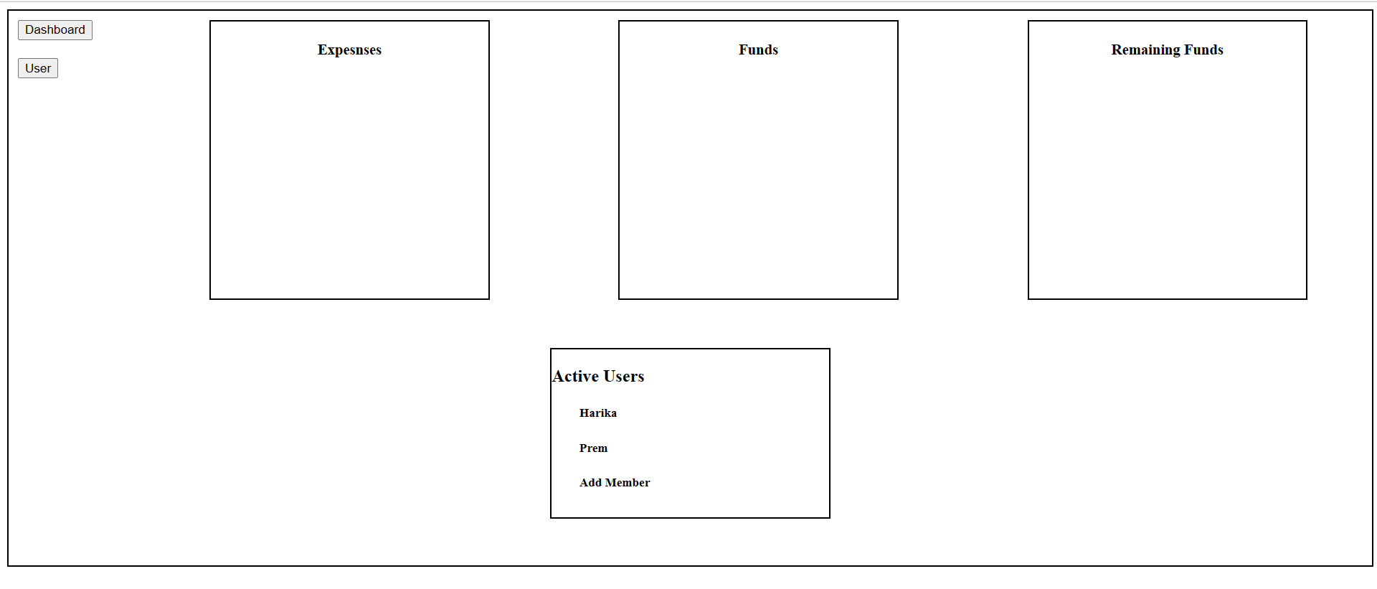

**Detailing of Expenses Card**

The expenses card should contain Date, Transaction Details, Amount, Expenses Category, Source, Spent By.

Date: Date of transaction.

Transaction details: Purpose of the expense(detailed).

Expense Category: Purpose of the expenses.

Source: Bank Name to be Displayed

Spent By: Display the person’s name.

Attachments: Bills or Receipts to be attached.

Cancel: To cancel the Transaction.

Submit: Submit the Transaction.

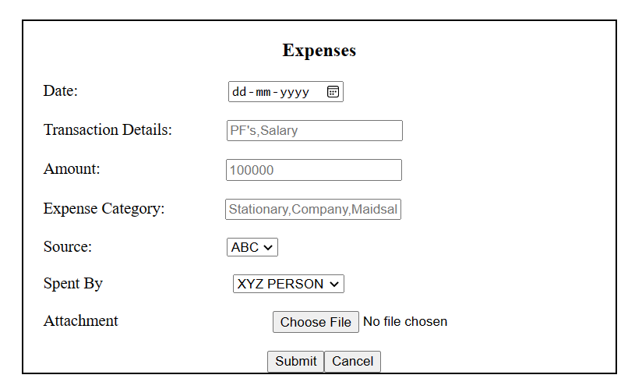

**Detailing of Funds Card**

In this card mainly there are three components. They are Source, CreditBy and Amount.

Source: In this we have to display the multiple options to add the fund (IDBI, Axis, PettyCash) .

After that we have to submit the details.

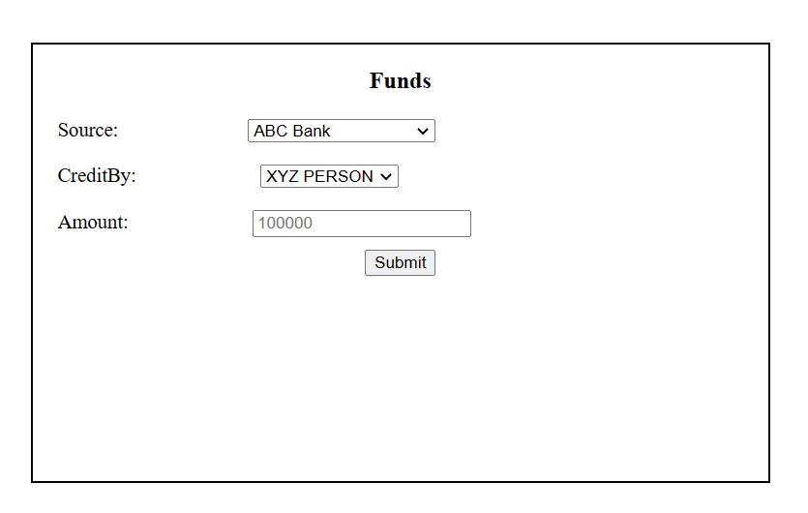

When the Admin Logins there should be a option to add the new source in the source list, like adding of new bank.

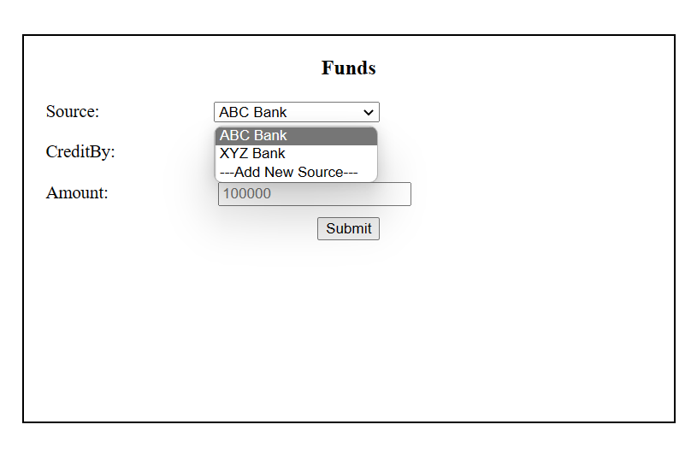

**Detailing of Transfer Card**

In the Transfer card there should be Name ID, Date, Transaction through, Amount ,Destination and Transferred to.

Name id should be unique and it should be generated by the combination of date, amount transaction through and transferred to. If there is a two transactions or multiple transactions in a day it should show count along with the name id.

Date : Display the money transferred date.

Transaction through : Source of money transferred.

Destination: The money transferred to which bank.

Transferred to: Display the money transferred to which person.

